A1150-AM,S- **Peru-**Chancay-Doll-Tapestry Face-1100 AD/CE

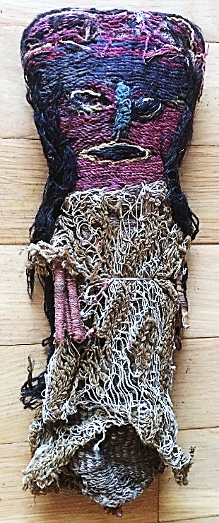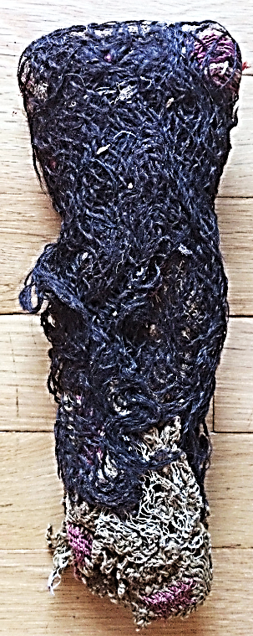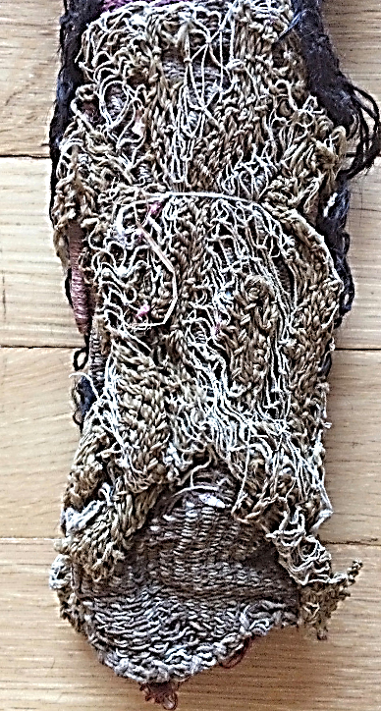 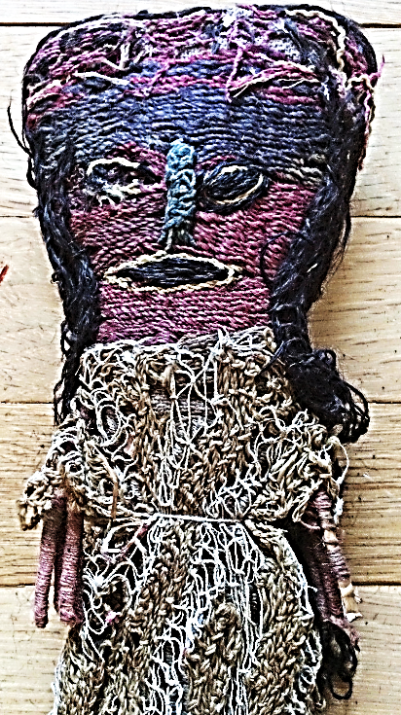

Figs 1-4. **Peru-**Chancay-Doll-Tapestry Face-1100 AD/CE

**Case no.: 7**

**Accession Number:**

**Formal Label: Peru-**Chancay-Doll-Tapestry Face-1100 AD/CE

**Display Description:**

The Chancay culture 1000-1470 AD/CE emerged on the central coast of Peru in the valleys north of Lima after the demise of the Wari Empire.

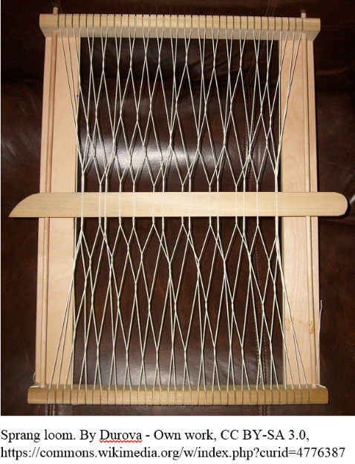 This original Chancay doll has a unique tapestry-woven face and a unique sprang-woven skirt and shawl. Sprang weaving is one of the oldest textile techniques, which is found in Peru as early as 700 BCE. This unusual loom technique is a very complex version of the cat's cradle. The fabric is created entirely from warp threads without any introduction of weft. The warp threads are stretched between two bars and the fabric is formed as the side by side threads are twisted over one another. This tapestry face is done in tones of purple, blue white and black threads, which is unusual and may have iconographic significance as a deceased ancestor as a guardian deity, since most faces are done in primary colors. These dolls offer a rare chance to closely examine the exquisite threads, fabrics and loom techniques from one of the world's most sophisticated textile cultures (Lehman 2005).

In the Chancay culture, these female dolls were placed in graves, and it is believed that they were meant to be guardian companions for the departing soul. Textile production was prolific and preservative in the dry, sterile air of the central coastal valleys of Peru.

**LC Classification:** F 3429.1 .C47

**Date or Time Horizon:** 1100 AD/CE

**Geographical Area:** Pisquillo Chico, Chancay, Lima, Perú

**Map, GPS coordinates: 11º34'6.61" S 77º14'13.9" W**

**Fig. 5. Sprang Loom.**

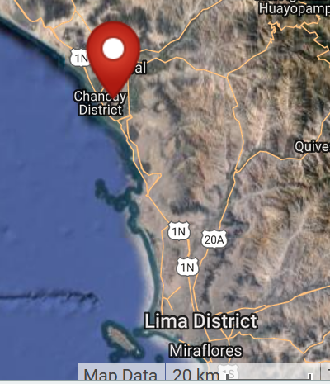

**Fgig. 6. Map.** Pisquillo Chico, Chancay, Lima, Perú

**Cultural Affiliation:** Chancay

**Media:** wool, dyes

**Dimensions:** H 25.4 by 10.16 cm, 10 by 4 in

**Weight:**

**Condition: original**

**Provenance:** acquired in Pisquillo Chico, Chancay, Lima, Perú, 1960.

**Discussion:**

Sprang weaving creates a mirrored symmetry; as each set of twists are formed, a corresponding twist is made in the opposite direction. As the twisted fabric forms at one end of the threads, the weaver pushes the mirrored twist up to the top of the cloth. When the twists meet in the middle, the center is secured either by twinning an independent thread through it or knotting it together. Control of the center area is critical to prevent the structure from unravelling. Since most sprang has too many fibers to manage by hand, rods or sticks are used to maintain the fiber positions. Decorative patterns can be introduced by regular variations in the fiber crossings. As crossings accumulate the material needs to be flattened.

The beautiful, complex patterns like this skirt are made when double or triple layers of threads are interlocked, producing elaborate, lacy patterns without sacrificing either elasticity or durability. Without this secured end, the fabric would simply come untwisted and the threads would lie side by side again. The thread was spun with a low whorl spindle from very fine cotton. A single thread has a very high twist that collapses into the open spaces of sprang, giving it even more texture and complexity (Evans 1995). Sprang produces very strong open work that is extremely elastic.

**References:**

Hodnett, M. K. 1999. *Pre-Columbian dolls in the Amano Museum = Muñecos precolombinos en el Museo Amano*. Lima, Perú: Museo Amano.

Lehman, Hattie Jo. 2005. “Textiles of the Chimú and Chancay cultures of coastal Peru woven during the Late Intermediate Period: a comparison of processes and techniques.” M.A.

“Representations of duality in a Chancay knotted weft wrapping headcloth in the collection of the Michael C. Carlos Museum.” M.A. Emory University.